The State Darwin Museum

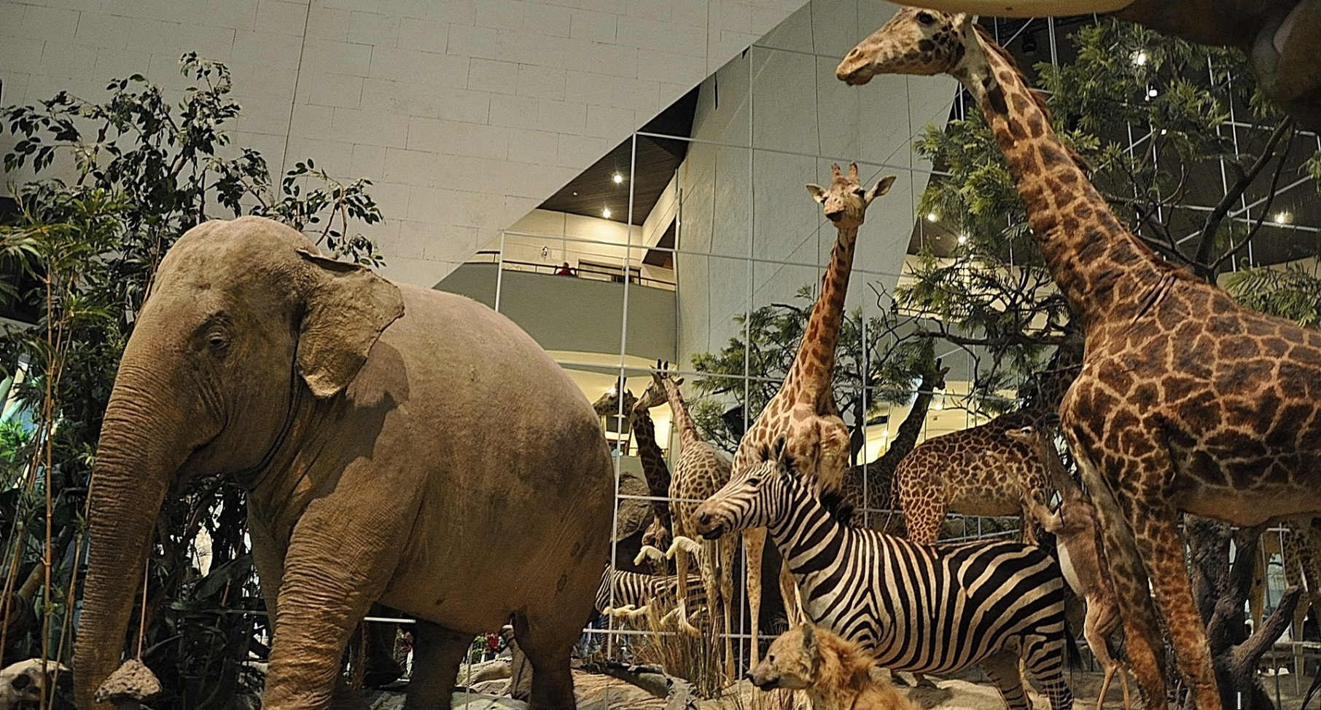

Before you visit the first level of the museum do the first three tasks.
Task 1
Read the text about the State Darwin Museum and decide if the statements are true (T) or false (F).

About Museum
The State Darwin Museum was opened in 1907 as an educational museum. It was the first museum of biological evolution in the world. Today the State Darwin Museum is the largest museum of natural science. It has three buildings with the total area of more than 20 000 sq. m. The museum collection includes about 400 000 exhibits.
The museum organizes more than 50 exhibitions a year, many conferences, seminars, ecological and family festivals. More than 500 000 visitors come here every year.

At the "Intermuseum" festival in 2007 the Darwin Museum was recognized as the best museum of the year and was awarded the Grand Prix.

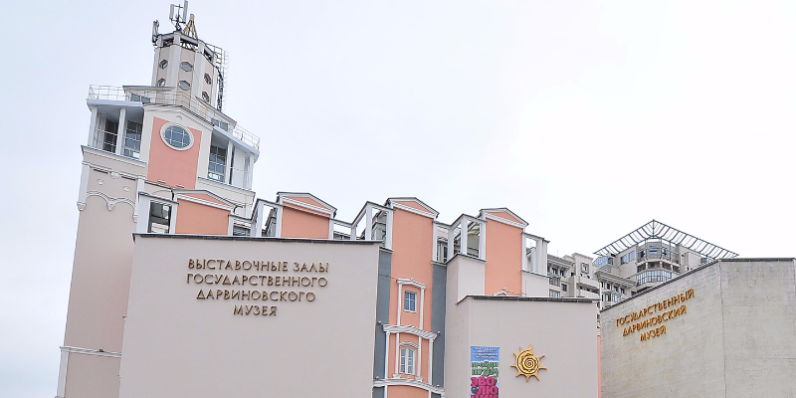
- The museum opened more than 100 years ago.
- The museum has two buildings.
- The museum is not very large.
- More than half a million people visit the museum every year.
- In 2007 The State Darwin Museum was named the best museum of the year.

Today you are going to take a tour of The State Darwin Museum. You will have to complete different tasks to guess a secret word at the end of the lesson. For unfamiliar words you may consult the Active vocabulary list on the last page of your worksheet.

Task 2
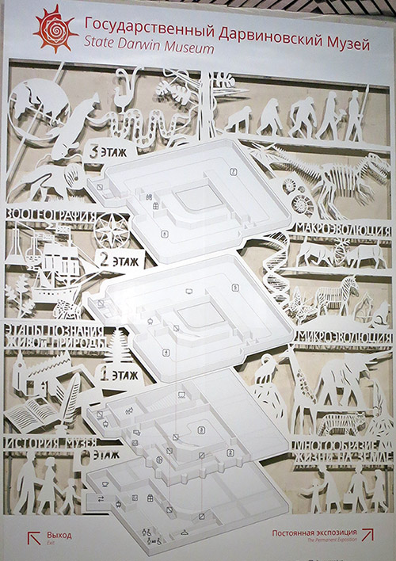
Study the map of the museum and answer the questions.

- How many levels are there in the museum?
- Where can you learn about the history of the museum?
- Where can you learn about the evolution of people?

Task 3

When we visit museums and exhibition halls we can move in different directions.
Match the icons with the phrases. There is one extra phrase.

- B. C. D. E.

- move straight ahead
- turn left
- move counter-clockwise
- move back
- turn right
- move clockwise

A | B | C | D | E

Go upstairs to the first level. The “Biological diversity” Hall
Task 4
You’re in the “Biological diversity” hall. Look around. Find these animals and write down the title of the showcase.
 | 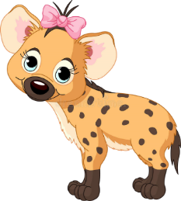
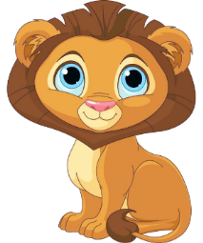 |  | 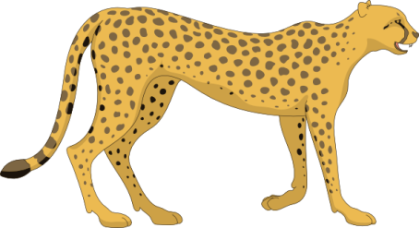

Task 5
Write down the names of these animals.
________________
________________
________________
________________
________________
________________

Task 6
Animals speak with each other and use different sounds. Choose the right sound for four animals from the previous task. Take the first letter from the sound which hyenas make to guess the secret word at the end of the lesson. It’s going to be the first letter of the secret word.
a. This animal usually trumpets. It’s very big.
b. This animal usually roars, growls, snarls. It runs very fast.
c. This animal usually roars and growls. It lives in the cold climate.
d. This animal usually laughs. It is one of the main characters in the Lion King cartoon.
1
A____________________
B____________________
C____________________
D____________________
Task 7
Where do the animals from task 6 live? Take the second letter from the name of the continent to guess the secret word at the end of the lesson. It’s going to be the third letter of the secret word.
a. North America
3
b. Antarctica
c. Africa
d. Australia
Task 8
Circle this continent on the world map.

Go upstairs to the second level. The “Microevolution” Hall
Task 9
You can see different scenes from animal lives around you. What are the following animals doing? Match the animals with the action.
The eagle are fighting with the elk.
The wolves are carrying the leaves.
The ants is attacking the hare.
What tense is used in these sentences? What else do eagles, wolves, elks and ants usually do?
______________________________________________________________________________________________________________________________________________________________________________
What is the difference between Present Simple and Present Continuous?
______________________________________________________________________________________________________________________________________________________________________________

Task 10
Look at the walls. There are many pictures on this floor.
a. Tick the pictures that are NOT from this floor.
b. Write one sentence to describe what is going on in each picture. We describe pictures in Present Continuous.
For example: The rabbit is playing on the grass.
c. Which of these pictures has the following names: “A farmer tending his animals”, “A lion attacking a horse”?
d. Give a name to each picture in the table by taking out the form of the verb “to be”.

Picture | Tick | Description
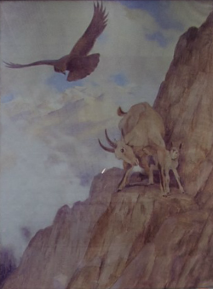
1.

 |  | Name
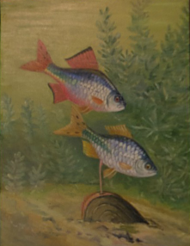
2.

 |  | Name
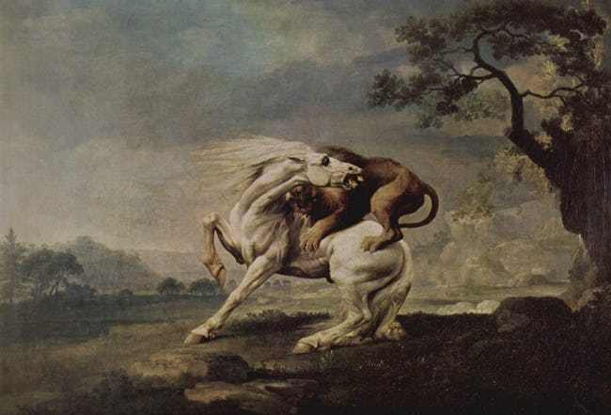
3.

 |  | Name
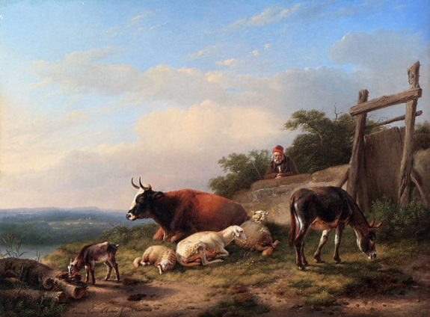
4.

 |  | Name
5.
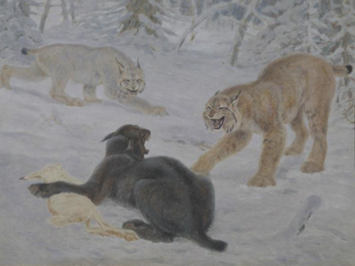

 |  | Name

Go upstairs to the third level.
The “Macroevolution” Hall.
Task 11
a. Use the scheme to find the man in the picture.

b. Which direction did you have to take to get to this place?

move straight ahead
move clockwise

move counter-clockwise turn left

turn right

Scan the information on the showcase window. There are some facts about the fauna in our flats.
c. Use the table to guess the names of the insects that live in our flats. The names are given in two languages (in Russian and English). Some letters are missing. You may use the Active vocabulary if needed.
d. Match the names of the insects with the proper pictures.
A | B | C | D | E | F | G

e. Tick the insects in the middle column, which are not described on the showcase window.
 | PICTURE | TICK |  | NAME
1 | 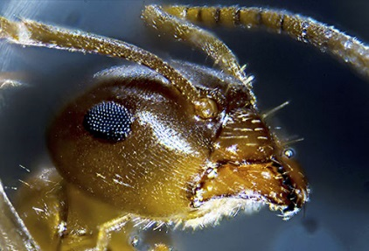 |  | A | _O_Q_IT_
 |  |  |  | _О_АР
2 | 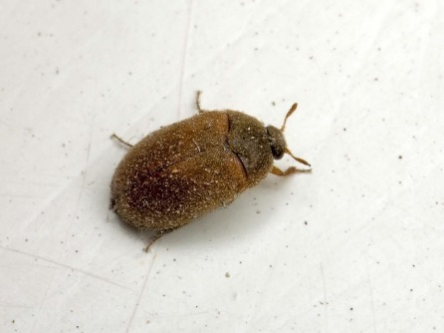 |  | B | _EN_IPE_E
 |  |  |  | С_Р_КО_О_КА
3 | 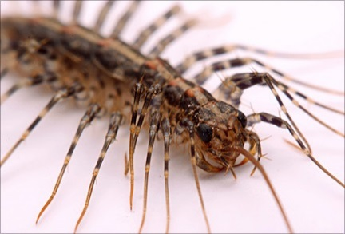 |  | C | BE_TL_
 |  |  |  | _УК
4 | 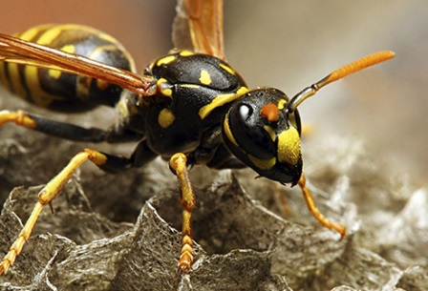 |  | D | A_T
 |  |  |  | МУР_ _ЕЙ
5 | 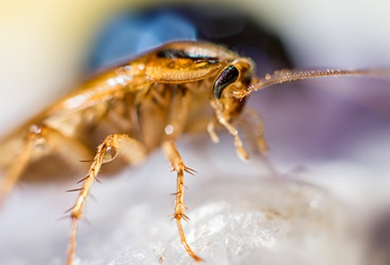 |  | E | FL_
 |  |  |  | М_Х_
6 | 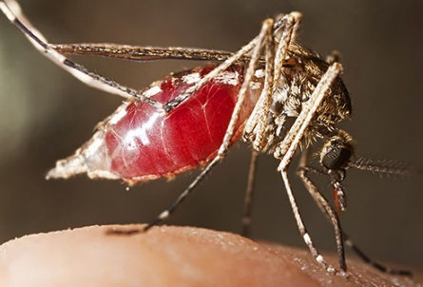 |  | F | W_SP
 |  |  |  | О_А
7 | 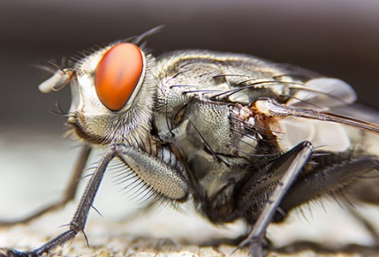 |  | G | CO_KRO_CH
 |  |  |  | ТА_ _КАН

Take the fifth letter from the name of this insect to guess the secret word at the end of the lesson. It’s going to be the second letter of the secret word.
2
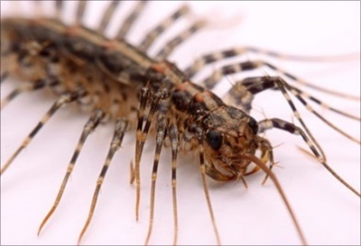

__ __ __ __ __ __ __ __ __
Task 12
Look at the pictures and colour only the dinosaurs.

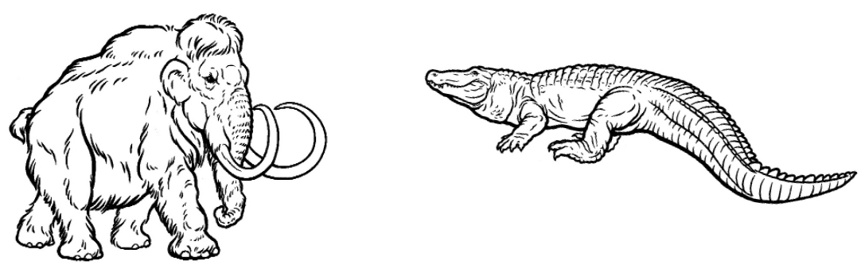

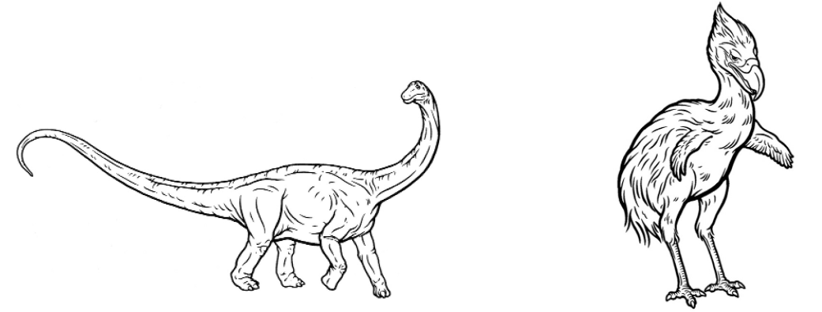

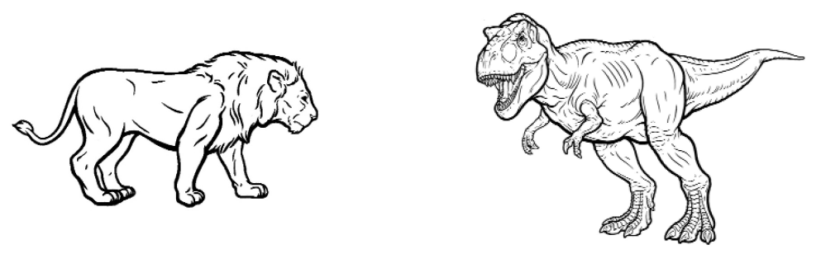

Task 13
These are different types of dinosaurs. These were enormous animals which lived on our planet many years ago.
Are there any dinosaurs on the second floor? ___________________________________________________________

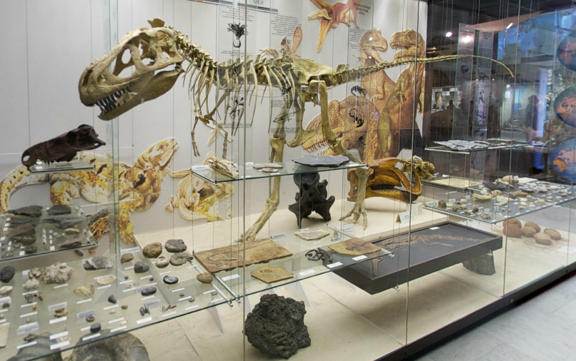
a. Use the scheme to find the dinosaur’s skeleton in the picture.

Write down the number of the showcase. ___________________________________________________________

b. Which direction did you have to take to get to this place?

move straight ahead
move clockwise

move counter-clockwise turn left

turn right

c. Choose the right names for the dinosaurs in the picture. Some of the letters in the names are missing.

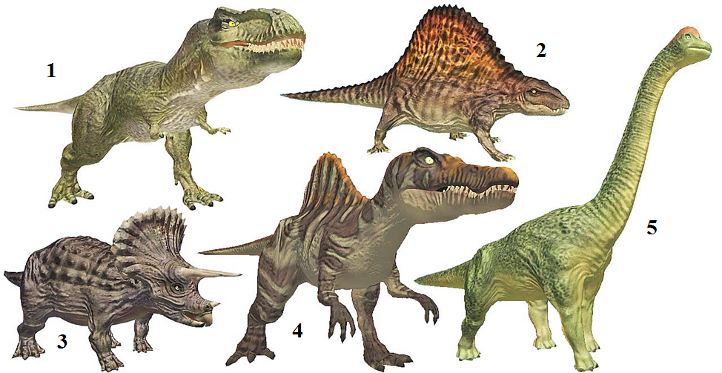

BRONT_SAURUS ST_GOSAURUS
TYRANNOS_URUS SP_NOSAURUS TRIC_RATOPS

Which of these dinosaurs can you see in the showcases? Tick the right picture.

Take the fifth letter from the name of this dinosaur to guess the secret word at the end of the lesson. It’s going to be the fifth letter of the secret word.
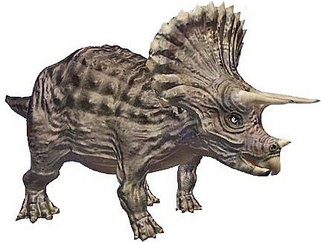
__ __ __ __ __ __ __ __ __ __ __
4

Final task

Now the time has come to guess the secret word. Look through the papers once again and fill in the missing letters.

Active vocabulary
biological diversity многообразие жизни
hyena гиена
growl рычать
showcase window стекло стенда в музее
laugh смеяться
roar реветь
elk лось
eagle орёл
mountain goat горный козёл
centipede сороконожка
ant муравей
wasp оса
cockroach таракан
mosquito комар
Brontosaurus бронтозавр
Stegosaurus стегозавр
Tyrannosaurus тираннозавр
Spinosaurus спинозавр
Triceratops трицератопс
Mountains горы
Rainforest тропический лес
Savannah саванна

