The Moscow Metro played a very important role during the Battle of Moscow. Study the map of the Moscow Metro in 1945. How many lines and stations were there? What stations are renamed nowadays?
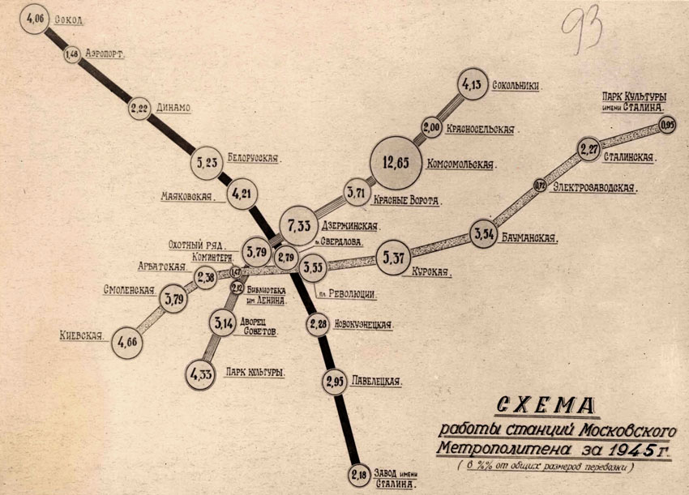
Visit http://mosmetro.ru and find out how many lines and stations there are in the Moscow Metro nowadays.

